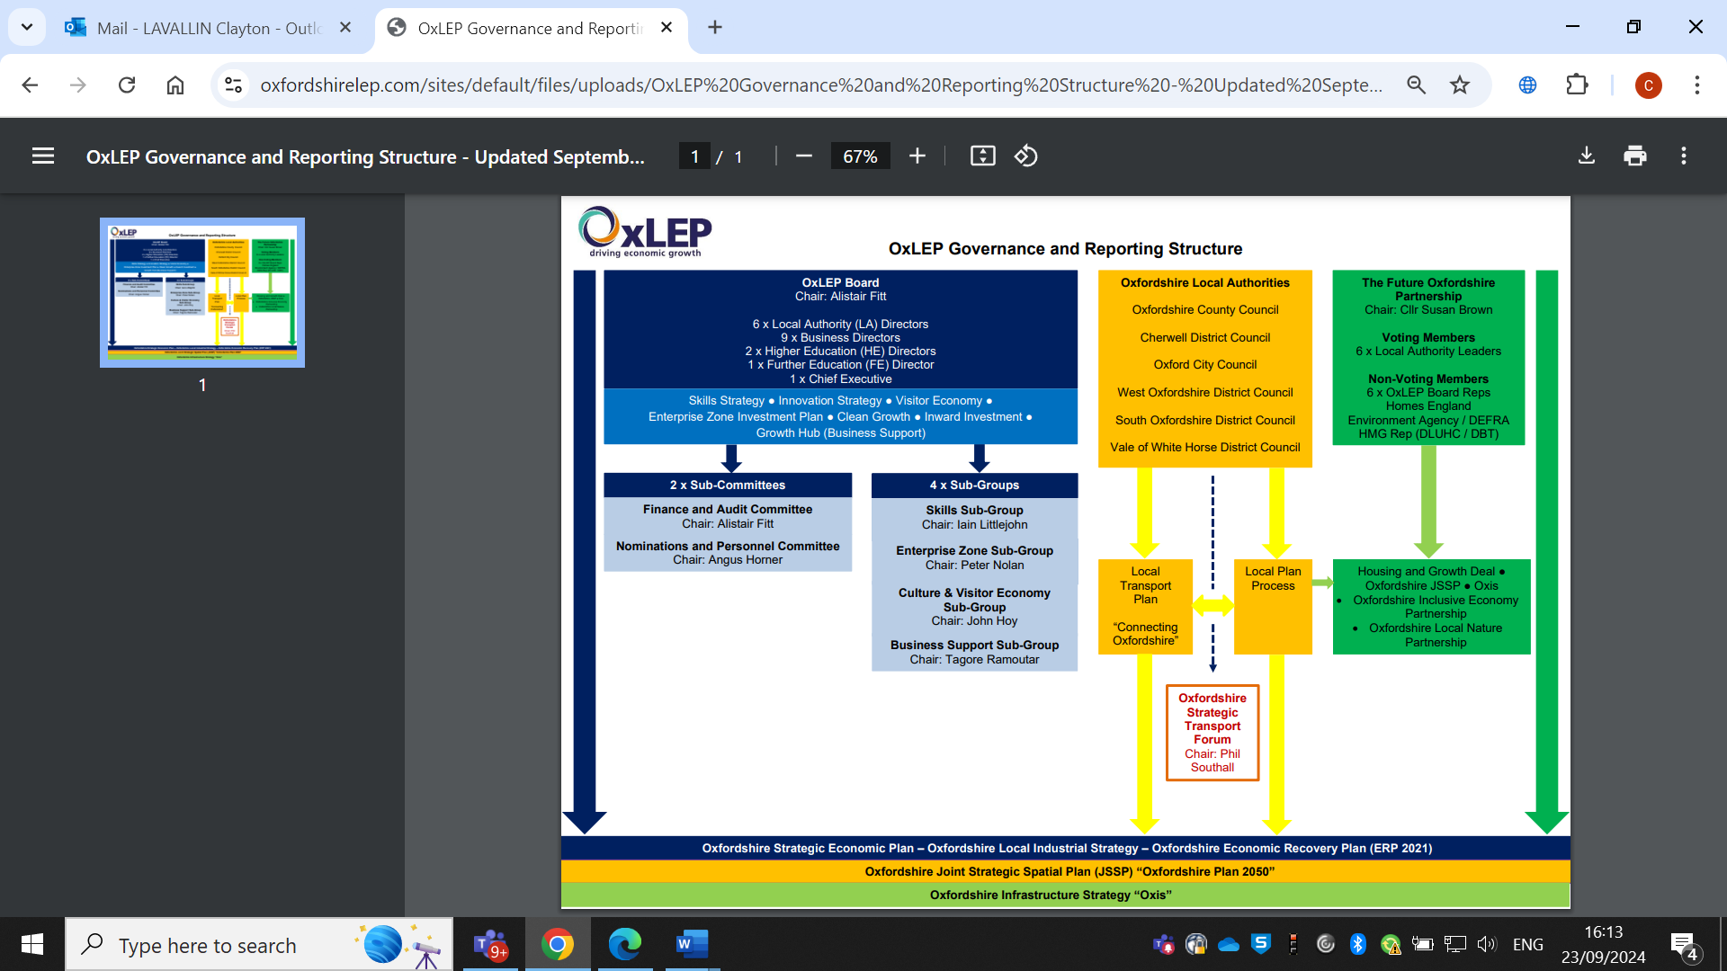

**OxLEP Governance and Reporting Structure**

**OxLEP Impact 23/24**

Highlights of some of the notable impacts of OxLEP activity:

* **1,792 businesses supported, 2153 Hours of support delivered** through webinars and workshops etc, 2,677 referrals to other programmes, including ERDF and Skills. (for full business KPIs please see section below)
* **Delivered the £1.64m Visitor Economy Renaissance Programme**-outputs are described below.
* **Continuing delivery of the £1.7m Social Contract Programme** – aimed at supporting those most impacted by the pandemic with new skills and training.
* The apprenticeship levy pot reached **£2.58m, exceeding the original target of £1.3m and the aspirational target of £2m**. The funds have optimised the levy for **185 new** apprenticeship starts.
* **Supported 58 secondary schools and colleges’ delivery of Gatesby Benchmarks** – a framework that sets out what world class careers provision in education looks like and provide a clear framework for its delivery.
* **Foreign Direct Investment Targets met** - see section below (for full breakdown of KPIs)

Strategy and Internationalisation

1. **Oxfordshire Strategic Economic Plan:** Aligned to its strategic economic planning function described in the LEP review, OxLEP lead and published a Strategic Economic Plan (SEP) in December 2023 following an extensive evidence based engagement process over almost 12 months. OxLEP have also finalised the associated Action Plan which highlights the areas of action required to support the SEP ambition.
2. **Oxfordshire Place Narrative/Oxfordshire Circular Economy:** As a requirement of the agreed LEP Transition Plan OxLEP developed a further engagement/workshop process with the County Council Cabinet in response to their desire to review the SEP to ensure a number of emerging strategies commissioned/developed by the County Council over the last 3/6 months are reflected and aligned. These strategies include Oxfordshire Place Narrative, Oxfordshire Circular economy Strategy & Action Plan. Several workshops and consultations (June-August 2024) were held with stakeholders and partners with the objective of curating growth in the most sustainable and practical way to support a just and fair society that sustains the economic and social wellbeing of our communities.
3. **Invest Oxfordshire:** OxLEP has updated and refreshed Seven Sector Brochures, available here- [Invest in Oxfordshire](https://www.oxfordshirelep.com/investing-oxfordshire). Also Investment focused ‘Oxford Calling’ has developed to promote the Oxfordshire innovation cluster and latest investment news [www.oxfordcalling.co.uk](http://www.oxfordcalling.co.uk)
4. **Foreign Direct Investment (FDI) outcomes for the year 2023/24**: over £570 million in investment, supporting over 2, 486 jobs. 46 FDI successes since April 2023, 13 at Band A , the highest investment band. Please see section below for full breakdown. Current targets for the last few years have been exceeded and FDI results continue to be strong.
5. **Export support provided via OxLEP Business: Growth Hub** saw 47 businesses engaged with the Export webinars and workshops and 70 hours of Export coaching and 1 to 1 support was provided to 9 businesses.
6. **Visitor Economy Renaissance Programme**

A £1.64 million COMF funded two year programme finalised as of March 2024. Key outputs achieved:

* + Successful delivery of nine marketing campaigns delivered to encourage overnight visits and spend in off peak periods
  + Visitor Economy Grant supported 52 with total grants allocated of £840,884.
  + 63 businesses received tailored digital support via Growth Hub
  + Business Visitor offer promoted at two key overseas events
  + Oxfordshire Welcome created by Experience Oxfordshire -over 150 businesses signed up
  + Destination Management Plan- funding to be secured

Business Support (OXLEP Business)

1. **Growth Hub Delivery Programme 2023/24**
   1. Activity and Funding

|  |  |
| --- | --- |
| **Activity** | **Funding available where appropriate** |
| Core Growth Hub support | £261k (funded) – total funding £437k |
| BIF 2 | £200k |
| Visitor Economy grants – 2 rounds over 1.5 years | £750k (final claims due in May) |
| West Oxfordshire Advisor sessions – both rounds completed | £13,500 |
| Code Red – Business Resilience – through to March 2025 | £27,500 |
| Supporting Ukrainian Nationals - Asylum Welcome – start Up support | £5,500 |

* 1. Programmes and Activities-support since April 23

|  |  |  |
| --- | --- | --- |
| **Programmes** | **Examples of webinars/workshops** | **Other activity** |
| Monthly OxBOost Networking – network of 280 | Understanding your B2B customers and how they have changed | Launch of Business Directory - 81 |
| Quarterly OxLEP Women in Business Networking – network of 169 | Crafting Compelling Business Stories | Progressing through final VEG 2 grant claims (completion May 2024) |
| Business Drop In – BIPC Oxford | Unlocking Your Export Potential | Launch of Networking home page |
| Start Up Bootcamps | Networking do’s, don’t and success strategies | Code Red – Resilience project – Collaboration with TVLEP and BBF |
| Mentoring | So You Want to Start a Business | WODC 121 advisor session to support Rural grant scheme |
| Strategic Business reviews | Growing from 2 to 5 staff | Refresh resources page |
| Investment Readiness Club | 5 A Day - CEO Targeted series | Development of a new website |
| Foundations to Growth | Using AI In Your Business | OxLEP Business showcase x 2 |
| Unlocking Export Potential | Digital Sale Masterclass | Facilitation of Net Zero/Carbon Reduction Group |
| Leadership Peer Network | Net Zero Master classes | Ukrainian Nationals - Asylum Welcome |
| Monthly newsletter on behalf of OxLEP | CXO Masterclasses | Finished Business Investment Fund grant scheme |
| 121 support (20 advisors) | Developing your purpose |  |

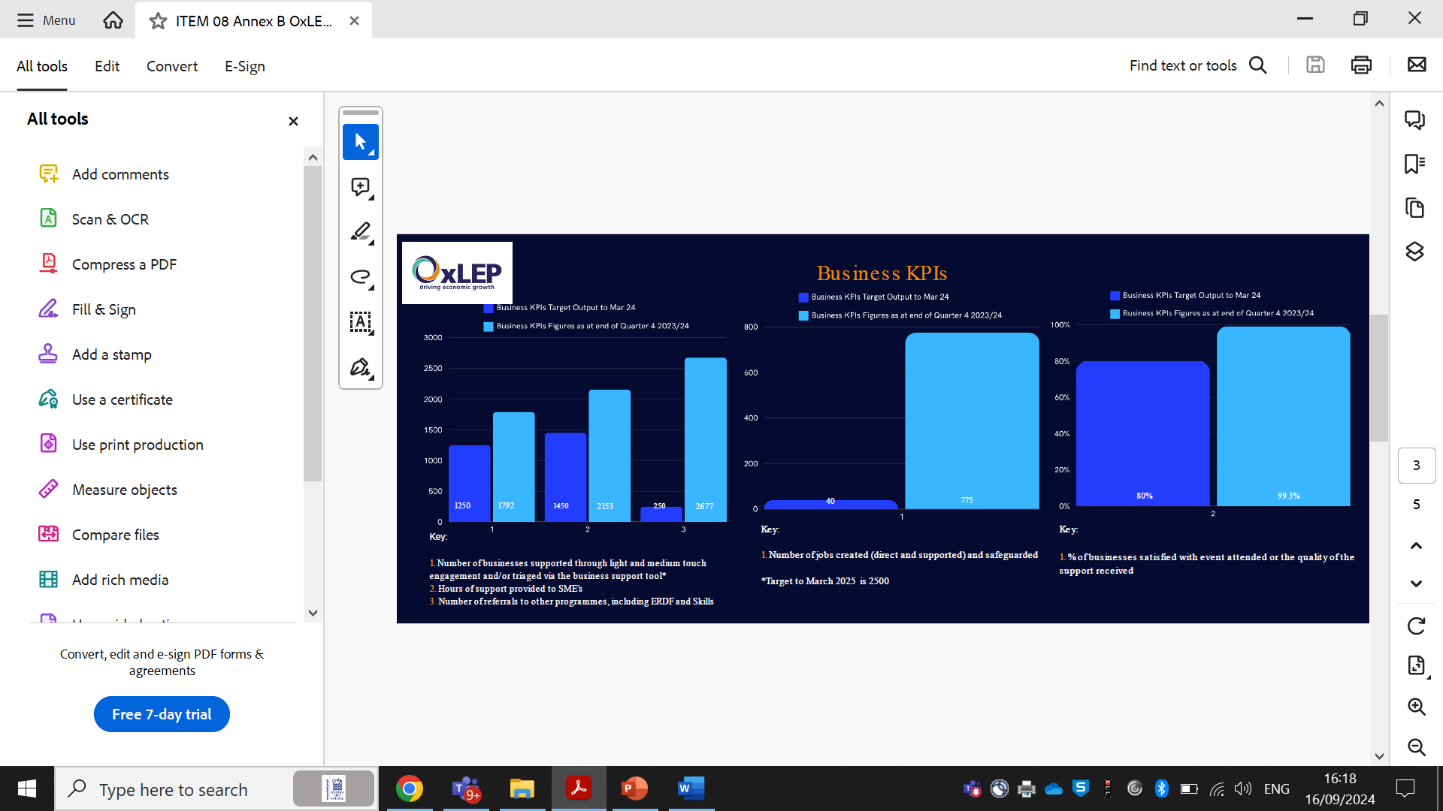

**Figure 1: OxLEP Business KPIs 2024/5**

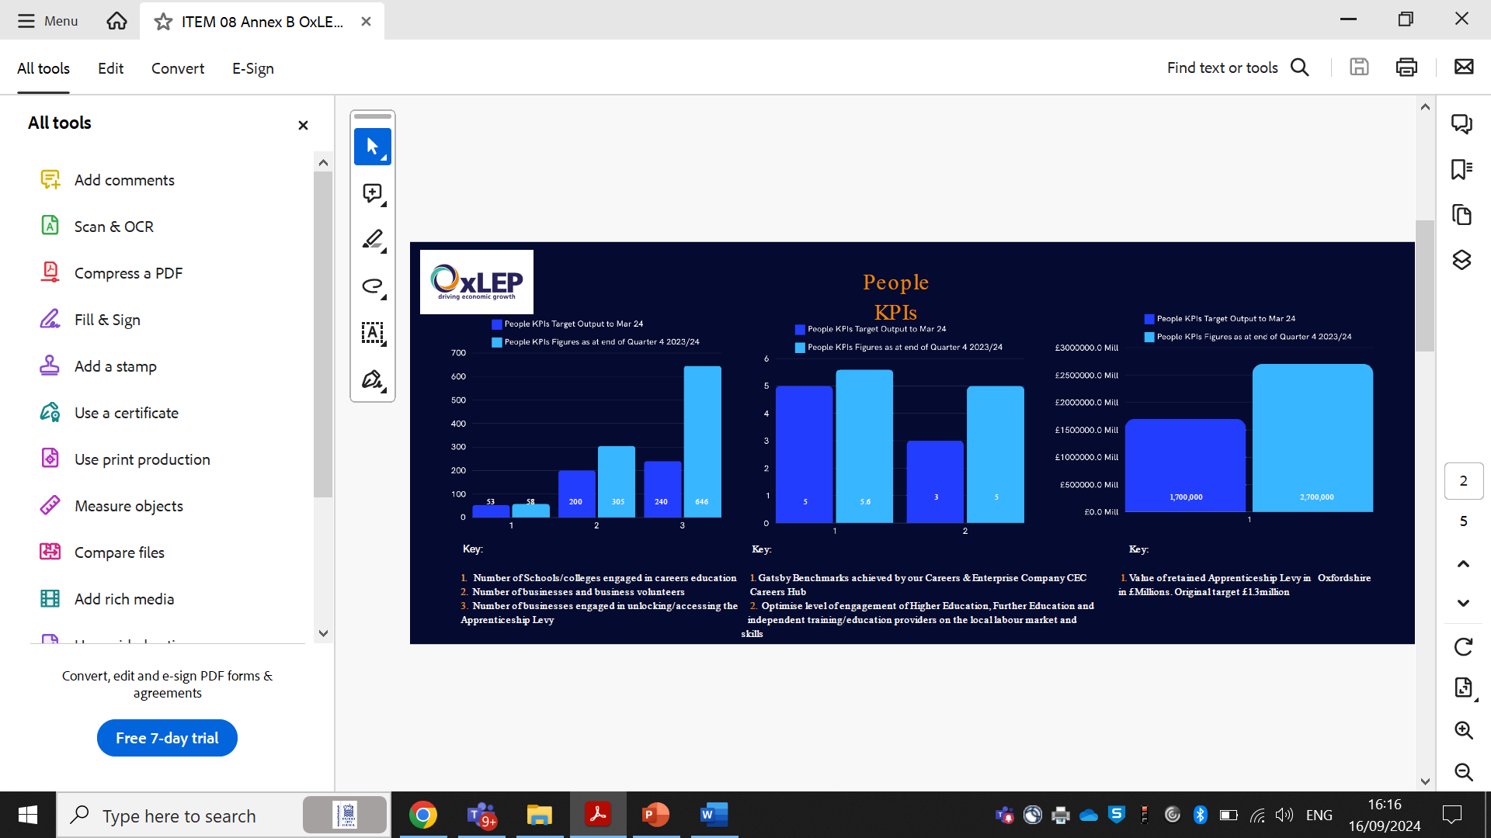

**Figure 2: OxLEP People KPIs 2024/5**

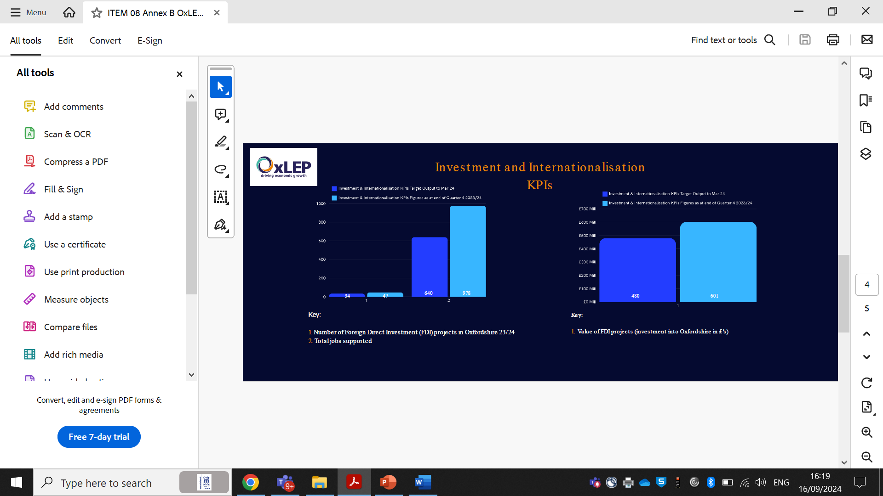

**Figure 3: OxLEP Investment and Internationalisation KPIs 2024/5**

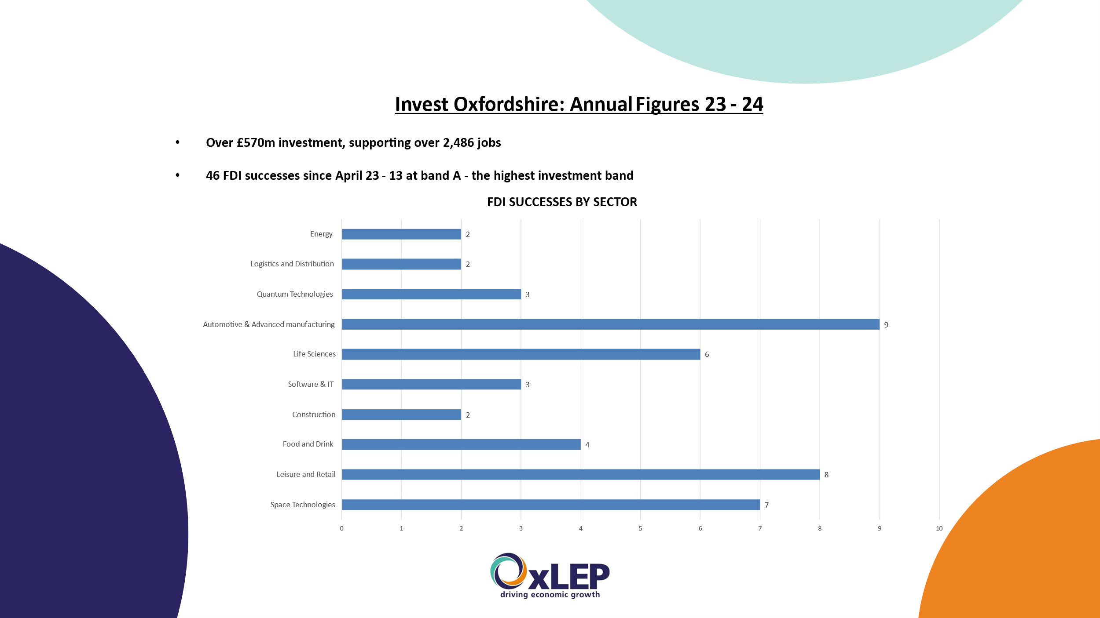

**Figure 4: OxLEP Foreign Direct Investment successes by sector 2023/4**

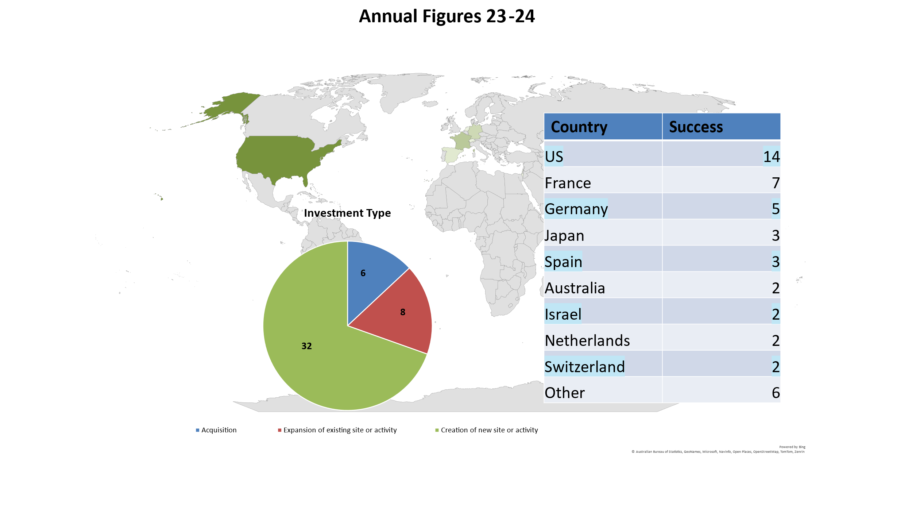

**Figure 5: OxLEP Foreign Direct Investment successes by country 2023/4**

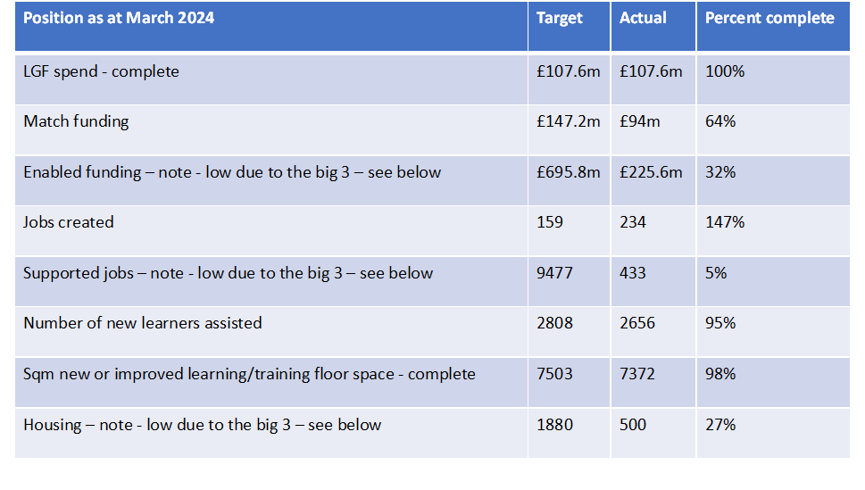

**Figure 6: Local Growth Fund (LGF)–HMG Deadline March 2025**

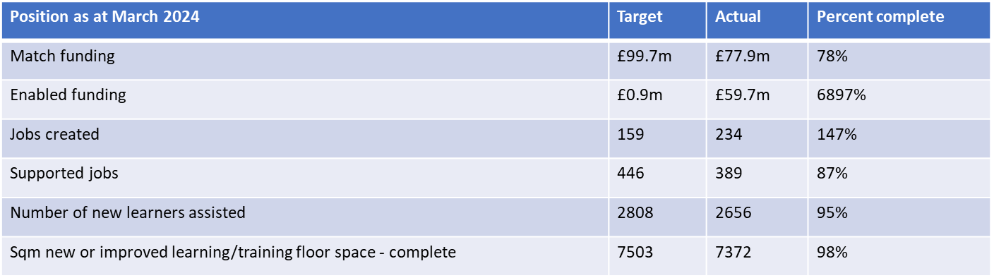

**Figure 7: LGF (minus the 3 major projects)–HMG Deadline March 2025**

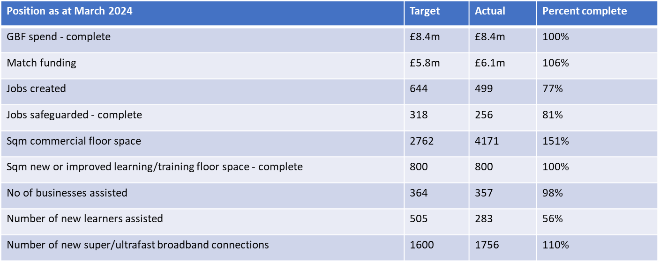

**Figure 8: Capital Programmes Getting Building Fund (GBF)–Deadline March 2025**

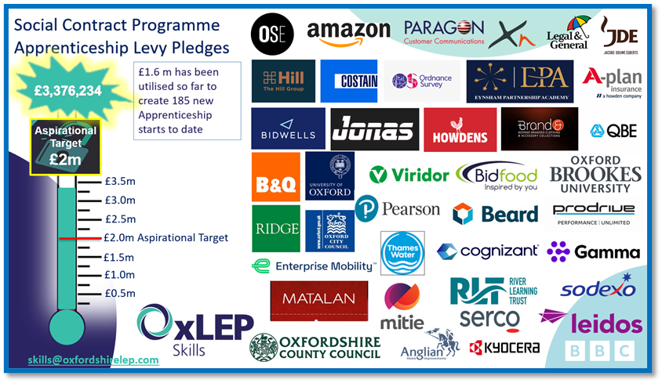

**Figure 9: Social Contract Programme Apprenticeships Levy Pledge total**

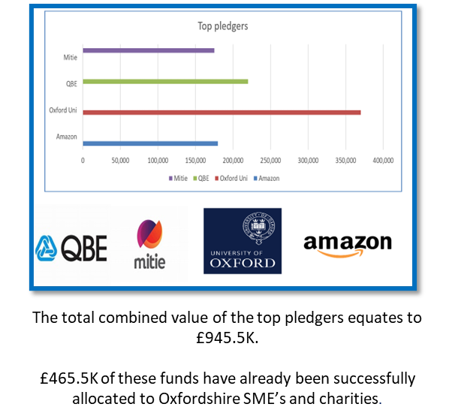

**Figure 10: Top Apprenticeships Levy Pledgers by Organisation**

|  |  |  |
| --- | --- | --- |
| **Activity** | **2 year target** | **Output to date** |
| Business support Tool | N/A | 691 |
| Business Support Plan’s | 2500 | 1792 |
| Hours of support delivered through webinars and workshops etc | 2900 | 2153 |
| Exporting specialist support - hours | 70 | N/A |
| Mentoring support - hours | 240 | 103 |
| Strategic business reviews – hours of support | 80 | 107 – target achieved |
| Jobs created | 80 | 222 – target achieved |
| Jobs safeguarded | 600 | 553 |
| Referrals | 500 | 2677 – target achieved |
| Business surviving beyond 6 months | 200 | 519 – target achieved |

**Figure 11: Growth Hub Support to date 23/4 and 24/25.**